The following institutes and organizations are the main developers of SQA and software engineering standards −

* IEEE (Institute of Electrical and Electronics Engineers) Computer Society
* ISO (International Organization for Standardization)
* DOD (US Department of Defense)
* ANSI (American National Standards Institute)
* IEC (International Electro Technical Commission)
* EIA (Electronic Industries Association)

**ISO 9000:2015 principles of Quality Management**

The ISO 9000:2015 and ISO 9001:2015 standards are based on seven quality management principles that senior management can apply to promote organizational improvement.

**[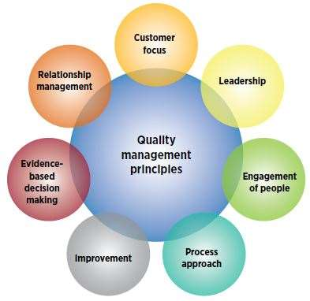](https://asq.org/quality-progress/2018/01/standards/under-the-wire.html)  
ISO 9000 Quality Management Principles**

1. Customer focus
   * Understand the needs of existing and future customers
   * Align organizational objectives with customer needs and expectations
   * Meet customer requirements
   * Measure [customer satisfaction](https://asq.org/quality-resources/customer-satisfaction)
   * Manage customer relationships
   * Aim to exceed customer expectations
   * Learn more about the [customer experience](https://asq.org/quality-resources/customer-experience) and customer satisfaction
2. Leadership
   * Establish a vision and direction for the organization
   * Set challenging goals
   * Model organizational values
   * Establish trust
   * Equip and [empower employees](https://asq.org/quality-resources/employee-empowerment)
   * Recognize employee contributions
   * Learn more about [leadership](https://asq.org/quality-resources/leadership)
3. Engagement of people
   * Ensure that people’s abilities are used and valued
   * Make people accountable
   * Enable participation in [continual improvement](https://asq.org/quality-resources/continuous-improvement)
   * Evaluate individual performance
   * Enable learning and knowledge sharing
   * Enable open discussion of problems and constraints
   * Learn more about [employee involvement](https://asq.org/quality-resources/employee-empowerment)
4. Process approach
   * Manage activities as processes
   * Measure the capability of activities
   * Identify linkages between activities
   * Prioritize improvement opportunities
   * Deploy resources effectively
   * Learn more about a [process view of work](https://asq.org/quality-resources/process-view-of-work) and see [process analysis tools](https://asq.org/quality-resources/process-analysis-tools)
5. Improvement
   * Improve organizational performance and capabilities
   * Align improvement activities
   * Empower people to make improvements
   * Measure improvement consistently
   * Celebrate improvements
   * Learn more about approaches to [continual improvement](https://asq.org/quality-resources/continuous-improvement)
6. Evidence-based decision making
   * Ensure the accessibility of accurate and reliable data
   * Use appropriate methods to analyze data
   * Make decisions based on analysis
   * Balance data analysis with practical experience
   * See [tools for decision making](https://asq.org/quality-resources/decision-making-tools)
7. Relationship management
   * Identify and select suppliers to manage costs, optimize resources, and create value
   * Establish relationships considering both the short and long term
   * Share expertise, resources, information, and plans with partners
   * Collaborate on improvement and development activities
   * Recognize supplier successes
   * Learn more about [supplier quality](https://asq.org/quality-resources/supplier-quality) and see resources related to [managing the supply chain](https://asq.org/supply-chain-management/)

| **ISO 9000** | **SEICMM** |
| --- | --- |
| ISO 9000 is a set of international standarads on quality management and quality assurance developed to help companies effectively document the quality system elements needed to an efficient quality system. | SEI (Software Engineering Institute), Capability Maturity Model (CMM) specifies an increasing series of levels of a software development organization. |
| Focus is customer supplier relationship, attempting to reduce customer’s risk in choosing a supplier. | Focus on the software supplier to improve its interval processes to achieve a higher quality product for the benefit of the customer. |
| It is created for hard goods manufacturing industries. | It is created for software industry. |
| ISO9000 is recognized and accepted in most of the countries. | SEICMM is used in USA, less widely elsewhere. |
| It specifies concepts, principles and safeguards that should be in place. | CMM provides detailed and specific definition of what is required for given levels. |
| This establishes one acceptance level. | It assesses on 5 levels. |
| Its certification is valid for three years. | It has no limit on certification. |
| It focuses on inwardly processes. | It focus outwardly. |
| It has no level. | It has 5 levels:  **(a).** Initial  **(b).** Repeatable  **(c).** Defined  **(d).** Managed  **(e).** Optimized |
| It is basically an audit. | It is basically an appraisal. |
| It is open to multi sector. | It is open to IT/ITES. |
| Follow set of standards to make success repeatable. | It emphasizes a process of continuous improvement. |